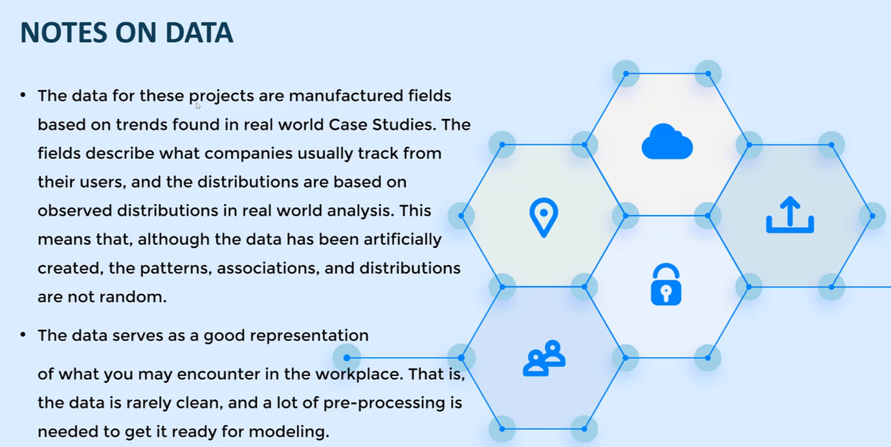Machine Learning: Using Cases in Fintech

Notes onModels Building

* Plotting: with Matplotlib, seaborn – a lot of time will be spent on Exploratory Data Analysis
* Data Manipulation – Use Pandas (and Numpy) for all of our data formatting steps
* Classification Models from Sklearn library (Logistic Regression and Regularization
* K-Fold Cross Validation, Grid Search (Parameter Tuning) and Feature Selection algorithms

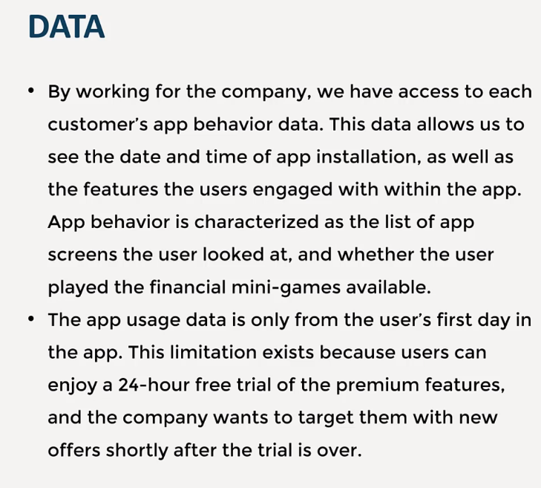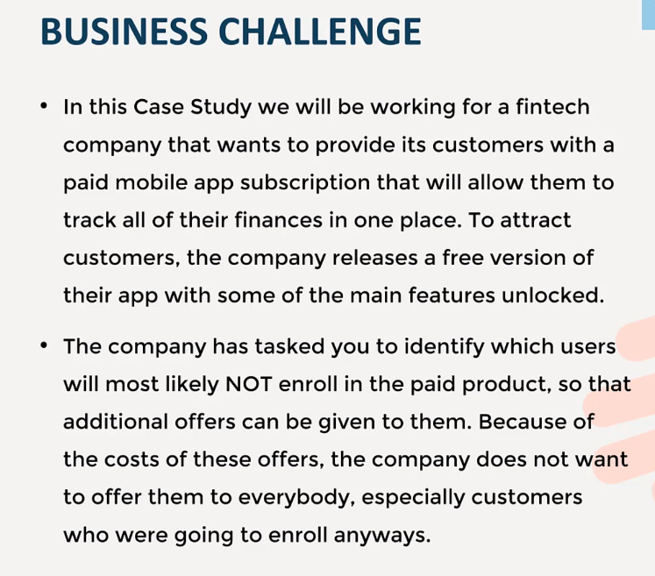Goal ; predict which users will not subscribe to the paid membership, so that greater marketing efforts can go into trying to ‘convert’ them to paid users

App behaviour is characterized as the list of app screens the user looked at and whether the user played the financial mini-games available.

Data Set Appendix10-

Userid, first_open, dayofweek, hour, age, sreen_list -> describe every single screen name the user has visited in the 24 hours, it is important. numscreens, minigame, liked, used_premium_feature, enrolled, enrolled_date

